# JOIN QUERIES

## **USE SQL Database 1**

## **CARTESIAN Product**

SELECT * FROM Table1, Table2;

What are the results – Paste a screen shot

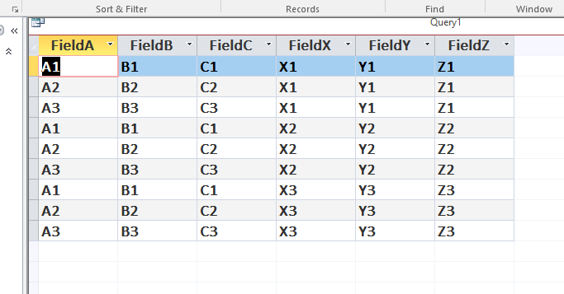

## **INNER JOIN**

SELECT Personnel.FullName, PersonnelPhone.Extension, Phone.DeviceType

FROM Personnel, PersonnelPhone, Phone

WHERE Personnel.PersID = PersonnelPhone.PersID

AND PersonnelPhone.Extension = Phone.Extension

ORDER BY Personnel.FullName ASC, PersonnelPhone.Extension ASC;

What are the results – Paste a screen shot

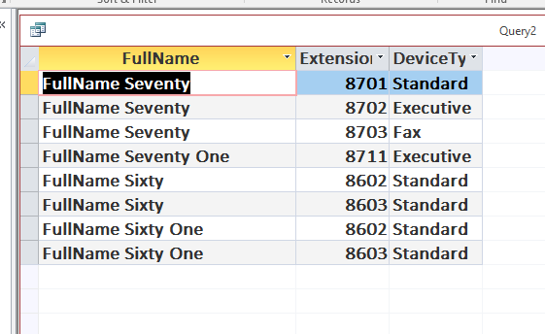

Do you get the same results with:

SELECT FullName, PersonnelPhone.Extension, DeviceType

FROM Personnel, PersonnelPhone, Phone

WHERE Personnel.PersID = PersonnelPhone.PersID

AND PersonnelPhone.Extension = Phone.Extension

ORDER BY FullName ASC, PersonnelPhone.Extension ASC;

If so WHY? – If not WHY not?

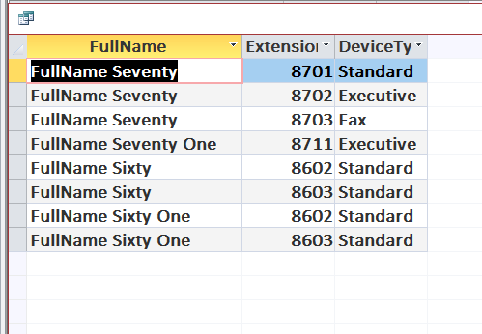

Because they came from the same table. So, putting the column name, “FullName” will bring the content and will draw the information from that. It is the same thing as putting the table name because there is one table containing FullName.

## **USE - SQL Database 2**

## **INNER JOIN Clause – 3 tables**

SELECT FullName, PersonnelPhone.Extension, DeviceType

FROM

(Personnel INNER JOIN PersonnelPhone

ON Personnel.PersID = PersonnelPhone.PersID)

INNER JOIN Phone

ON PersonnelPhone.Extension = Phone.Extension

ORDER BY FullName ASC, PersonnelPhone.Extension ASC;

What are the results – place screen shot here

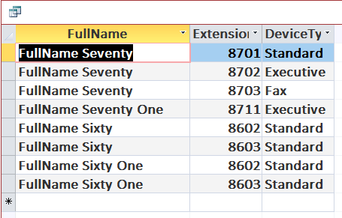

## **SELF JOINS and Aliases**

SELECT Pers.PersID, Pers.FullName, Manager.PersID, Mgr.FullName

FROM Personnel As Pers, Personnel As Manager

WHERE Pers.Manager = Manager.PersID

ORDER BY Pers.PersID ASC;

What would the INNER JOIN clause look like – write your query below, then place a screen shot of the results.

SELECT Personnel.PersID, Pers.FullName, Manager.PersID, Mgr.FullName

FROM (Personnel INNER JOIN Personnel

ON Pers.Manager = Manager.PersID)

INNER JOIN Mgr

ON Mgr.FullName=Pers.Manager

ORDER BY Pers.PersID ASC;

Run the queries relating to aliases from Moodle – Place a screen shot of your results.

